**Change Request -Tour Package**

1. Change in Location Setup:
   1. Location setup
      * 1. Addition of Country field
           1. Required
           2. Dropdown
           3. Allow partial search
           4. The user will be able to select a single value.
        2. Add a new column named “Country” in the location list after the location name
        3. Addition of image field in Location
           1. Upload Image

Required

Upload of image file

* + - 1. Addition of Tag identifier field in location.
         1. Dropdown
      2. Addition of tag short Order
         1. Numeric field
         2. Optional
         3. Showing position from 1-6 for mobile app
         4. The user will not be able to select the save value 2nd time as the system will not show the value in the already used list.
         5. If the user wants to use the earlier used one value with any other one then the user has to remove the earlier setup and then will be able to save the current one.
         6. The user will be able to add more tags identified along with tag short order no
         7. The user will be able to remove this information as well.
         8. Based on the setup the system will show the location under the tag identifier in the web part.

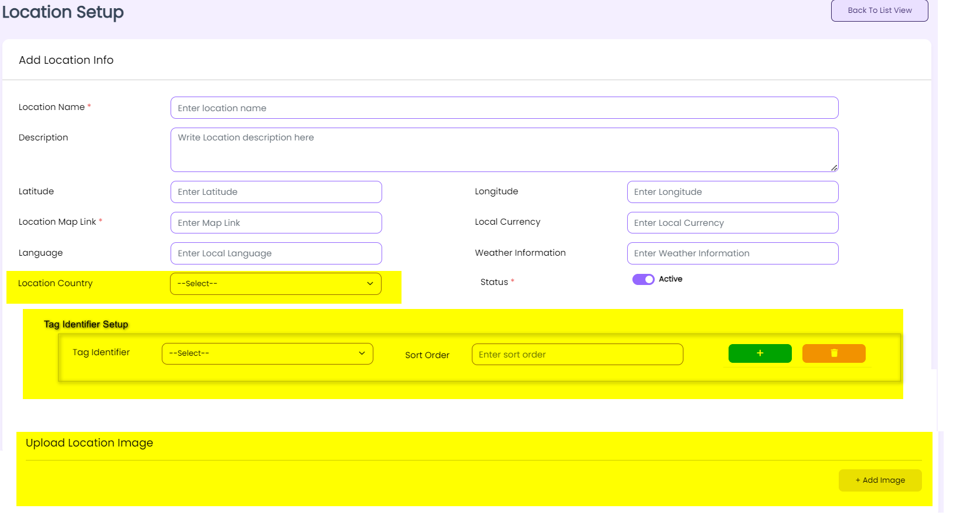

*Figure: Change in Location*

1. Change in Package Tag setup
   1. Addition of Tag identifier field in package tag setup
      * + 1. Dropdown
          2. Optional
          3. The user will be able to select a single value
      1. Based on the setup, the Mobile app will show the “Vacation for all” Segment
   2. Package tag name
      1. Add font color change option here
      2. The users will be able to change the font color
      3. Based on the selected font color the system will show the font in the front end and in the list view of the package tag after saving.
   3. Remove the “next trip tag” from this UI

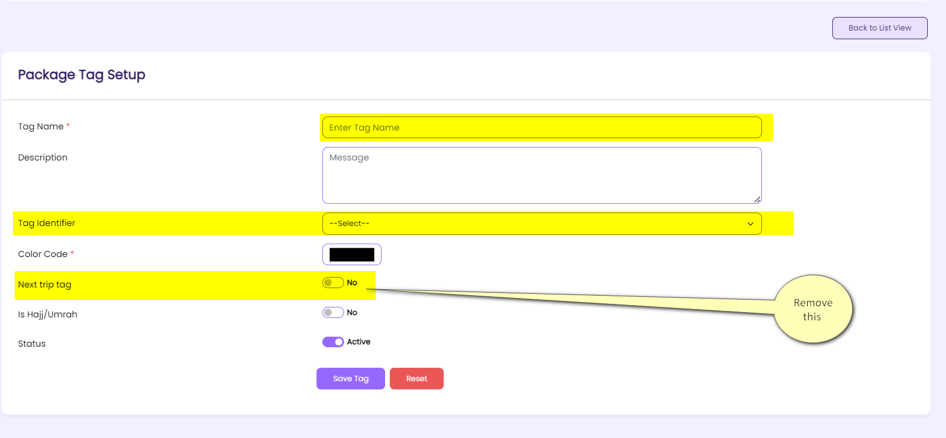

*Figure: Change package tag*

1. Addition of tour description field in the Package creation UI
   1. Tour description
      1. Free text field
      2. Required
      3. The user will not be able to add more than 200 characters here

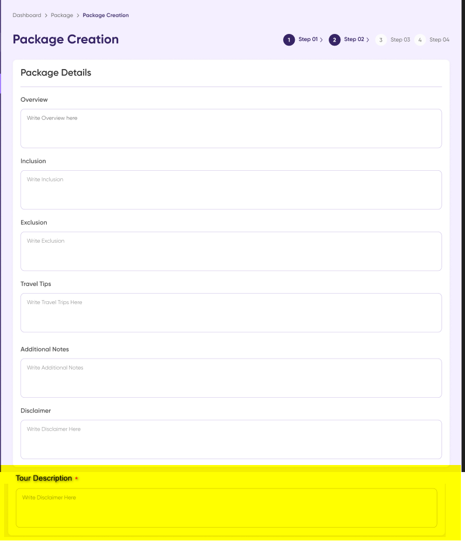

* 1. Other policy
     1. Addition of text editor
  2. Rearrangement of selection of Hajj/Umrah check box
  3. Based on the selection of the hajj/umrah check box the system will allow the user to select package category and package tag

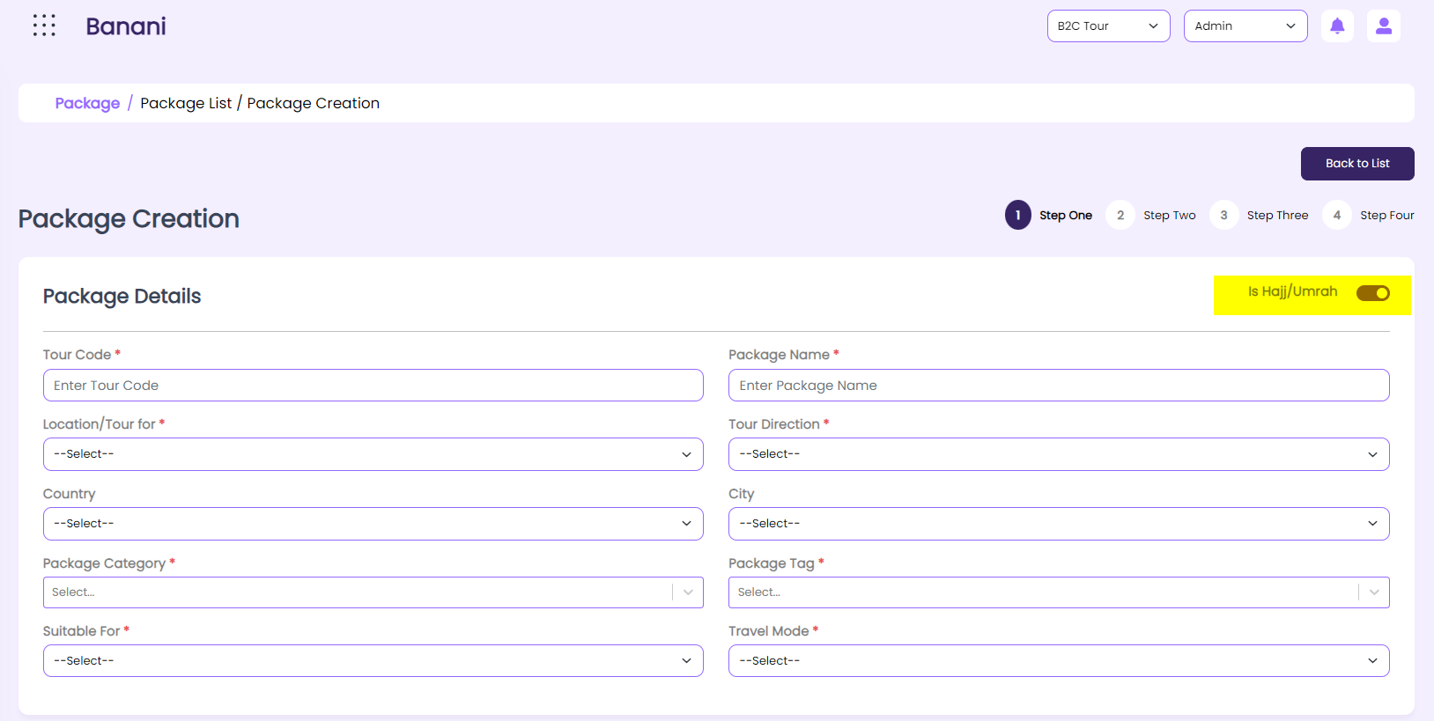

1. Addition of tour description field in the Package Booking UI
   * 1. Tour description
        1. Free text field
        2. Required
        3. The user will not be able to add more than 200 characters here



1. Change in admin part (General policy setup) to accommodate the segment “Holiday for every budget in web and mobile app
   1. Addition of 3 rows in the general policy setup UI
      1. Budget level 1
      2. Budget level 2
      3. Budget level 3
         1. Required
         2. Numeric value
         3. Based on the entered value the system will show the budget level in the web and mobile app.
2. Change in Child policy setup description field
   1. Addition of text editor in the
   2. Remove the description filed from the child policy list
3. Change in refund policy setup description field
   1. Addition of text editor in the
   2. Remove the description filed from the refund policy list
4. Changes in the web part
   1. Placement of Hajj /Umrah navigation button
      1. Current behavior: The Hajj/Umrah navigation button will show beside the Tour package
      2. Expected behavior: The navigation of Hajj/Umrah will be with the other services and by selecting “Hajj/Umrah” the system will take the user to the Hajj/umrah package list.
   2. Removal of customized package option for Hajj /umrah
      1. Current behavior: All the Tour Package and Hajj/Umrah features will be the same.
      2. Expected behavior: There will be no customized tour inquiry option for Hajj/Umrah.
   3. Adding “preferred journey date” to the tour inquiry page
   4. Popular destination in landing page- web
      1. Based on the tag identifier addition in the location the system will show the location-based package in the list
      2. Add the writing in the location card named” Starts from”. The system will show the lowest price of the tour package of that particular location here. Example: Starts From 2500 BDT